**Download and Setup PyCharm for Learning**

In the coming lessons, we'll be using the PyCharm Integrated Development Environment to learn to code. It's a completely free piece of software and is used by professional Python developers across the globe. They also have a handy course template feature, which we'll be using for the beginner parts of the lessons from Day 1 to 15. So while you might have another favourite code editor, I only recommend to use PyCharm for this course.

**Step 1**

Download and install Python to your computer. Head over to the official Python website to download the latest version of Python for your computer system. Then complete the installation.

<https://www.python.org/downloads/>

**Step 2**

Download the Free Community Edition of PyCharm using the link below:

<https://www.jetbrains.com/edu-products/download/#section=pycharm-edu>

**IMPORTANT: If you already have PyCharm, make sure you update to the latest version of PyCharm otherwise the steps below might not work!**

**Step 3**

Once PyCharm installs successfully, you should see the welcome screen. Click on the Learn tab and click "Enable Access".

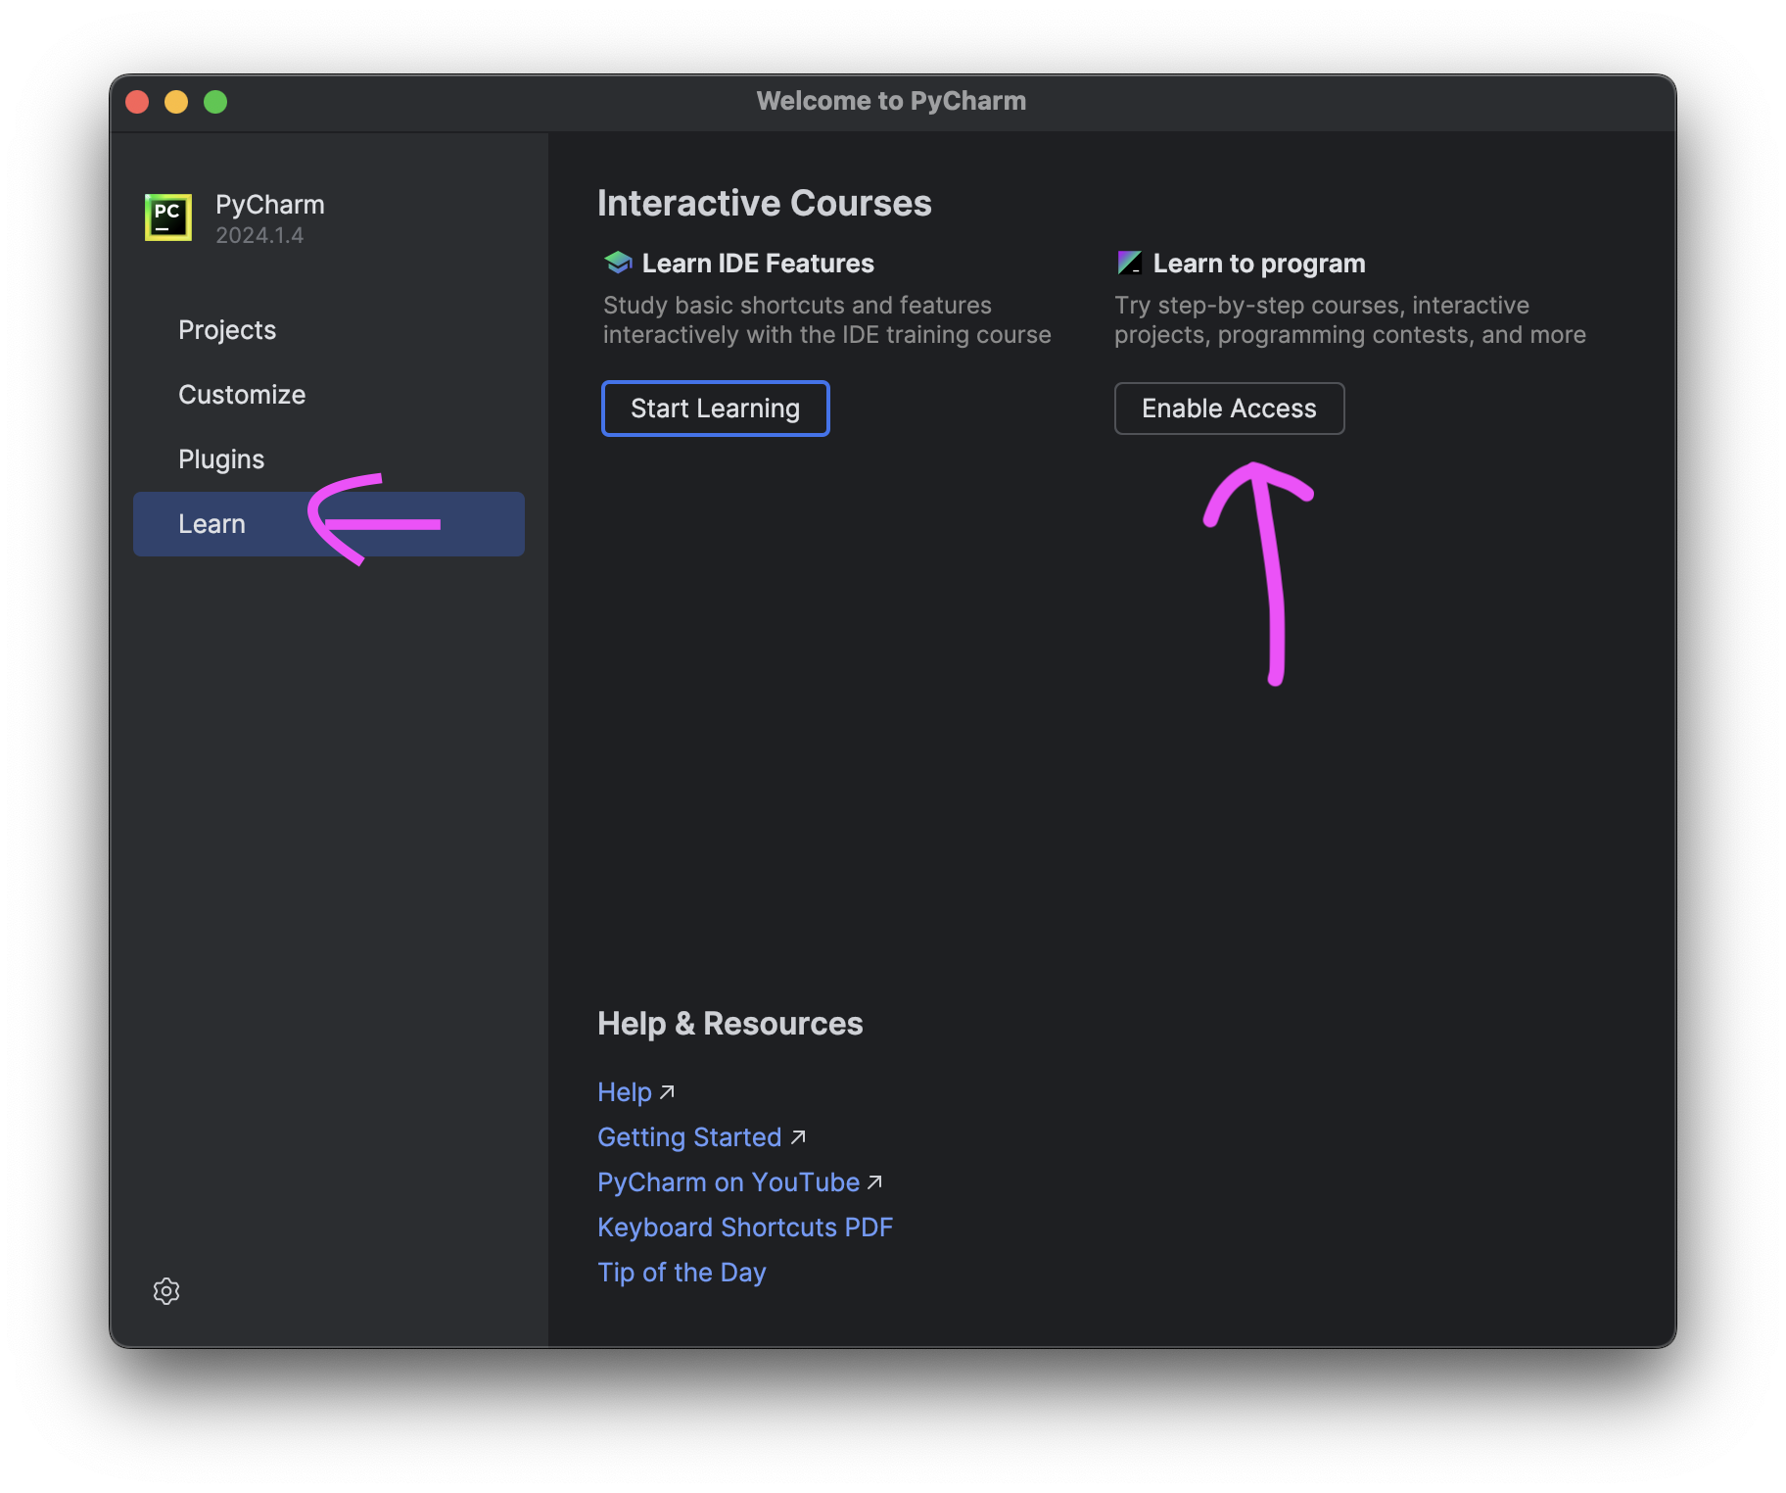

**Step 4**

Once all the required plugins install successfully. Close and Restart PyCharm.

**Step 5**

Head over to the link below and click "Open in PyCharm".

<https://plugins.jetbrains.com/plugin/25212-100-days-of-code--the-complete-python-pro-bootcamp?noRedirect=true>

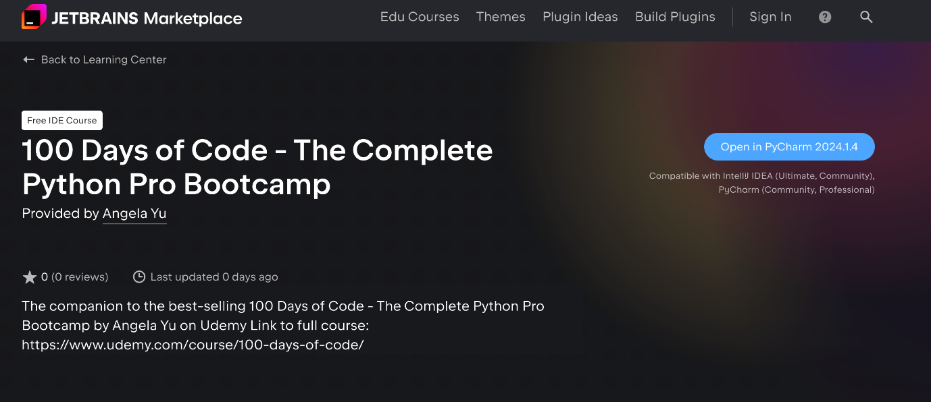

**Step 6**

It should take you directly to the course. If it does not work, you can also go to File -> Learn and Teach -> Browse Courses.

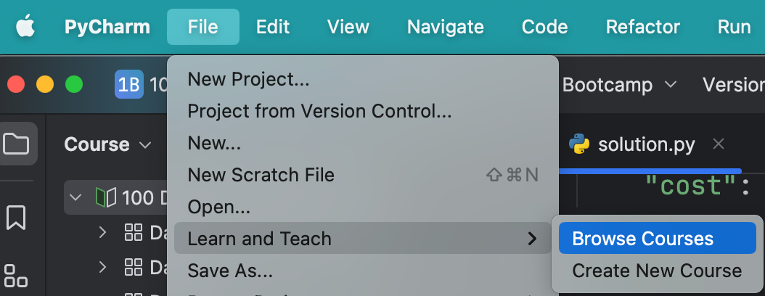

Next, scroll down to find the course: 100 Days of Code - The Complete Python Pro Bootcamp and click "Start". You can also search for it in the search course area.

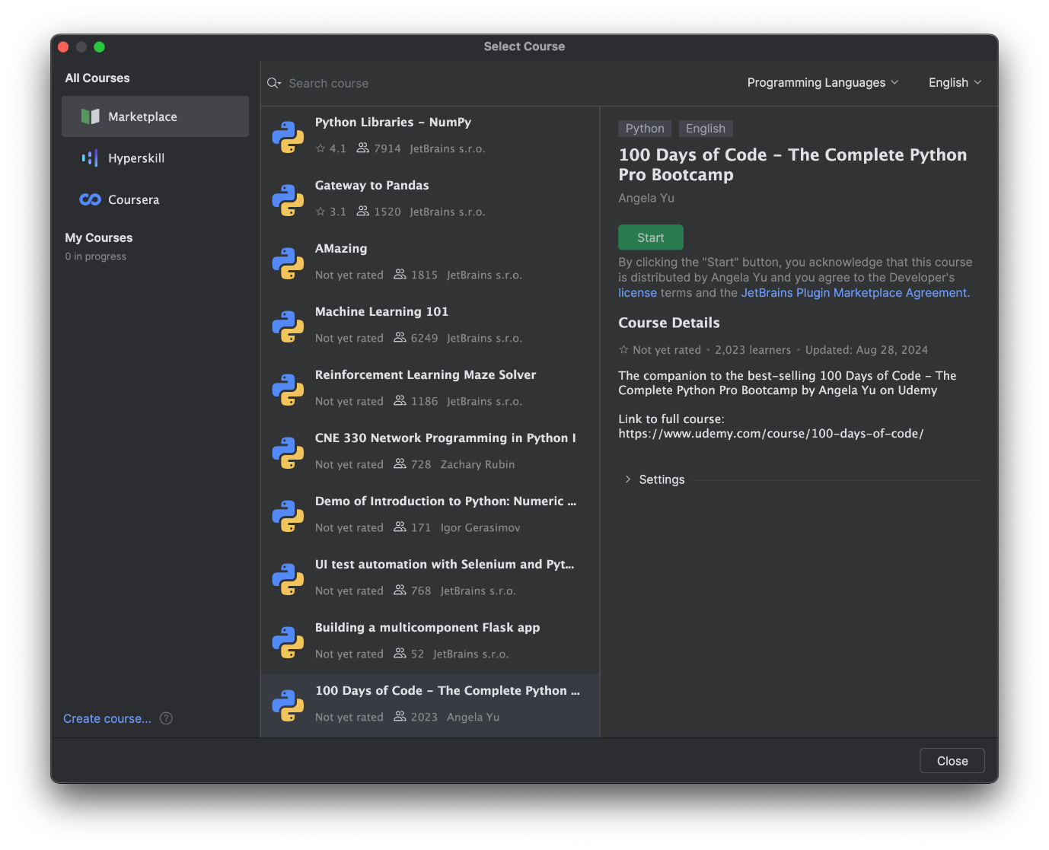

Now you should have access to the beginner course (Day 1 - Day 15) on PyCharm. You will be guided through the lessons to go from Task to Task (you can see the task numbers on the right pane e.g. 1 - 6 for Day1).

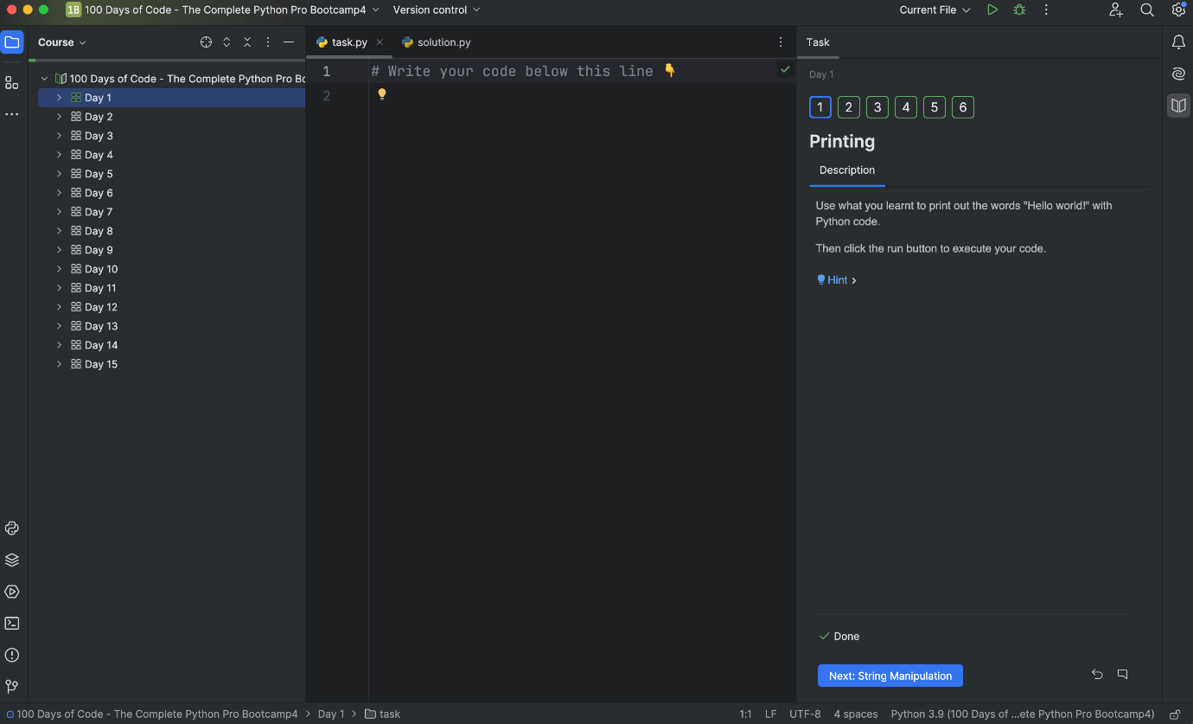

NOTE: This course project covers the lessons for Day 1 to Day 15. After that, you will be creating your own projects in PyCharm (or your preferred IDE).

**Editor**

=========Python Editor===  
replit.com -- online editor  
vscode

GitHub for Group project - <https://github.com/>

**Refer Notes for Python**

[The Python Tutorial — Python 3.13.1 documentation](https://docs.python.org/3/tutorial/)

**=== Database ===**

<https://sqlbolt.com/>

===> we can download almost any book's pdf for free

<https://www.pdfdrive.to/>

===> Massive bundle of Python courses. A lot of AI and image generation stuff..

<https://www.humblebundle.com/software/complete-python-mega-bundle-encore-software>

==> <https://cs50.harvard.edu/python/2022/>